**CSC2021 Advanced Programming using C# and C++**

**CSC2022 Games Programming using C# and C++**

**Project Report:**

**Team Details and Project Aims**

|  |  |  |
| --- | --- | --- |
| Name | Student Number | Preferred Email Address |
|  |  |  |
|  |  |  |
|  |  |  |
|  |  |  |
|  |  |  |

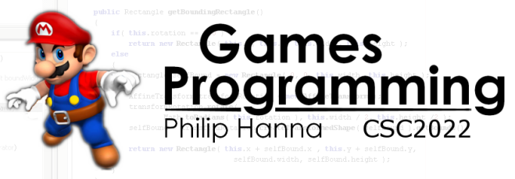

Within the project you will play the part of a development studio creating an Android game. When referring to your team I would really like to avoid saying ‘let’s see what team 23 have done’ – as such you have an opportunity to give your team a name and a bit of fictional background (there might even be a prize for particularly creative, entertaining or insightful team outlines).

|  |
| --- |
| Studio Name |
| [[Enter the name of your development studio here]] |

**[Optional] Logo:** If desired, insert your studio’s logo (graphic) below.

**[Optional] Mission Statement:** If desired, include the mission statement of your studio below.

This section records your initial thoughts and ideas about the type of game you plan to develop. I will provide feedback on the level of challenge and the degree of mapping onto the marking scheme.

Very, very important: What you write here does not constitute a binding agreement; instead it simply represents your initial goals as to the type of game that you would like to develop. As the project develops you will almost certainly change your ideas and your original plans. This is not a problem – you should expect it to happen

|  |
| --- |
| Title |
| [[Enter the title of the game you plan to develop]] |

|  |
| --- |
| Overview |
| [[Provide a brief overview of your proposed game, i.e. genre, aims, play style, etc.]] |

It’s 100% ok to remake an old game, or to propose something entirely new.

Identify in the table below the functionality that you consider to be core, desirable and optional.

|  |
| --- |
| Core functionality |
| * [[List core functionality here]] |
| Desirable functionality |
| * [[List desirable functionality here]] |
| Optional functionality |
| * [[List optional functionality here]] |

You can think of core functionality as something that must be in the game for it to work. For example, in a Breakout clone the ability to move the bat and hit a moving ball are core items of functionality. We can define desirable items as those that would be very nice to have, but are not strictly necessary. For example, our Breakout clone should have a scoring system, but without it the game is still playable. Optional functionality is anything not covered by the above. For our Breakout clone this might include fancy graphical effects.

When introducing functionality please be mindful that: the duration of the project is limited; you will have to learn and experiment with different approaches to get a working game; resources will be limited, etc.

**Very important:** If you find that most of your items of functionality are in the core list then stop and rethink your project! Ideally, your core list should be reasonably small, with a larger desirable list and as many optional features as you want.

If not already done, carefully read the project assessment criteria document.

With specific reference to the assessment criteria, which aspects of your proposed game do you feel would enable you to score highly against the stated assessment criteria?

|  |
| --- |
| Project aspects that are aligned with the 1st class category |
| [[Provide details of the aspects of your game that strongly contribute to the defined assessment]] |

**Important:** In order to score very highly your game does **not** need to be graphically rich **and** feature packed **and** complex. You will get to decide how important each of these areas are, and also how they will be weighted within the final assessment. At this stage, you should think about what type of focus is most appealing (be it on one or two areas or a balance across all areas).

Based on the information you supply I will provide feedback on your game, the challenge you face and your initial development plans.

Summary feedback information will be provided below. You will also receive more detailed audio feedback (i.e. a pod-cast) that will expand on the summary feedback provided below. If the feedback is unclear, or you didn’t get feedback on something you want, then please do ask and I’ll happily provide additional feedback!

Warning, this is highly demanding

Be careful, this is demanding

Should be doable with some challenge

Perfectly adequate and doable

Warning, not enough to attract high marks

Your project should be meaty enough to potentially attract a good mark and also provide a rich learning experience. However, it should also be doable within the time and resource available.

**Challenge**

In order to best reward the time and effort you put into your project, it is important your project maps well onto the assessment criteria (although you will have a lot of say over how the project is assessed).

Perfect – excellent opportunities across all criteria

Good – excellent opportunities for most criteria

Acceptable – a number of matched criteria

Cautious – some criteria not fully covered

Warning – one/more criteria not covered

**Mappings onto marking criteria**